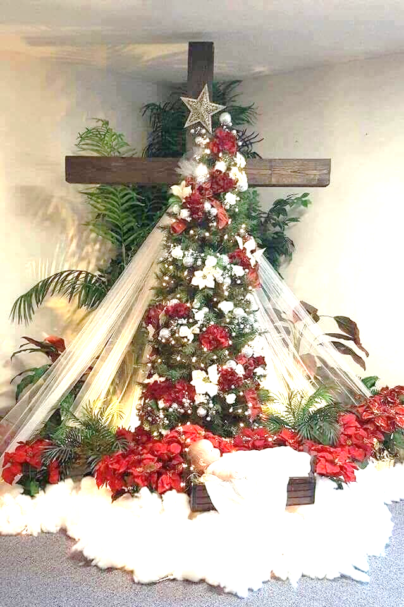

**December 25, 2022****E**

Welcome to

Bancroft Congregational Church

***BCC’s Transformative Paradigm***

# Isaiah 9:6

For unto us a Child is born,  
Unto us a Son is given;  
And the government will be upon His shoulder.  
And His name will be called  
Wonderful, Counselor, Mighty God,  
Everlasting Father, Prince of Peace.

***Ministries of our Church***

**Small Groups:** Wednesdays 10am;

Thursdays 6:30pm

***Mission Meeting*** *– 2nd Monday 10 am*

***CE Staff Meetings*** *- 2nd Monday 6:30pm*

***Karate*** *– Thursdays*

***Elder’s Meeting*** *- 2nd Wednesday 7 pm*

***Ladies Fellowship*** *– 2nd Wednesday 7pm*

***Men’s Prayer Breakfast*** *– 2nd Saturday 8 am*

***Food Pantry Distribution*** *– 3rd Saturday 10- Noon*

***Office Hours***

*9:00am – 2pm*

***M-F***

*Onsite days vary*

Pastor Todd – 9-3pm M, W, TH

***Tues. by appointment;***

i

**This Week’s Workers**

Greeter: Sally Labadie

Greeter: Jr. Love

Nursery: n/a

Nursery: n/a

Sound: Isaac Zander

Computer: Vaeh Cooke

Call to Worship & Prayer James Huguelet

Prayer Elder: Carl Cooke

Jr. Church Teacher: n/a

Jr. Church Helper: n/a

Scripture Reader & Message Prayer:

Laurie Valade ~ Isaiah 9:6

Benediction: Carl Cooke

Financial Team: James Huguelet

Financial Team: Dan Bryant

Communion (Jan – Carl Cooke)

**Next Week’s (Jan 1, 2023) Workers**

Greeter: Lee Habermehl

Greeter: Cyndy Habermehl

Nursery: Cathy Taber

Nursery: Laurie Valade

Sound: Matt Post

Computer: Kaylee Siddens

Welcome/Call to Worship: Brian Reed

Prayer Elder: James Huguelet

Jr. Church Teacher: Sharon Lewis

Jr Church Helper: Amber Bias

Scripture Reader & Message Prayer:

Vaeh Cooke ~ 2 Corinthians 5:17-20

Benediction: Lee Habermehl

Financial Team: Layne Valade

Financial Team: Dan Bryant

Communion (Next week: Carl Cooke)

***Prayer Requests***

**People:** Shut-ins: Dorothy Bruno; Janice Hoshal

Barb Compton;

the sick; unsaved loved ones

**Missionaries & Ministries:** Debbie Price (RBM); Kathy Coon (OMS); John Lowrey (Global Outreach); Kathy Curtis (Camp Barakel);

Youth Haven Ranch; Shad and Sara Deal (Ethnos360).

The Johnsons (ABWE)

Diane Lepior (HEARTS Ministries)

Dottie Hoppe (Pan American Missions); Mary Lou Wunker OMS

***December*** ***Tithes & Offerings***

***General Fund***

 Monthly Goal: $12,462

Received to date: $23,570

***YTD***

***Yearly Goal $162,000***

Year To **Date** Goal: $ 42,000

Received to date: $ 41,966

YTD

**General Announcements:**

* **December 22- 30th** – The office will be closed. If you have an urgent need the phones will be on call forwarding. If you have a prayer request, please contact your elder.
* **January 7th** – The Christmas decorations will be taken down and stored. If you can help, please see the signup sheet in the overflow room or talk with Lee Habermehl
* **January 12th** – The Sonbeams (small group that meets on Wednesday evenings) will be changing their meeting night to Thursday beginning January 12th. 6:30-8:30 pm. See you there!
* **January 15th** –Youth Group meeting
* **January 29th** – Young Adults at Valade’s home

***Sunday Worship Hours***

**Christian Education**

**9:45am-10:45am**

**Worship Service**

**11:00-Noon**

***Offering from* Dec 18, 2022**

Benevolent $ 0

Pantry $500

C.E. Offering $105

Youth Group $120

Building Maintenance $ 0

Missions $600

OCC - $ 0

Total Offering $ 2,648

**Announcements**